User guide
jWebSocket
C# Client Library
Version 1.0

Version Control
Date | Version | Description | Author
12/02/2012 | 1.0 | Creation of the document | Rolando Betancourt Toucet

- Characteristics of the solution

The user guide should explain the demo and its usage, so in this paragraph I would expect some introduction to this demo and the UI. The library features should be explained in the developer guide, but of course a quick introduction is fine here.
The C# Client Library is a collection of classes and functions that are responsible for managing the connection and transfer data between jWebSocket framework and an application in C#. This communication uses the WebSocket protocol thereby achieves real-time communication on the Web and improved application performance.

2. Main functionalities
- Start the connection with the jWebSocket framework.
- Allow exchange data with the jWebSocket framework.
- Terminate the connection with the jWebSocket framework.
The Client Library C# can be used by any developer or institution wishing to make an application. NET using the programming language C# and pretend to integrate with the framework jWebSocket. You can develop desktop applications or both console and web applications developed using ASP .NET.
3. Problems to be solved
Problem | Contributions of the solution
Improve productivity and reliability of real-time applications with the programming language C# using the framework jWebSocket  This is not a problem, this is an action, what is the problem ? E.g. nothing available, but unfullfilled user demand? C# apps up to now cannot communicate with browser or mobile apps. | Client library written in C# programming language in which applications developed using C# can be integrated with the jWebSocket framework. Which problem is solved by that?

4. Glossary
Real Time Web: It is possible when the client receives messages from the server without prior request and end users receive updates simultaneously.

WebSocket: It is a technology that provides a bidirectional communication channel and full-duplex over a single TCP socket. This protocol solves the limitations of HTTP, by establishing a full-duplex communication (TCP) between the client and server, replacing the half-duplex communication (HTTP). Is reduced, in large proportions, the network traffic given that WebSocket to establish communication between the client and the server there is only one overhead of 2 bytes, eliminating the HTTP headers.

Framework jWebSocket: Is a new technology oriented to developing WebSockets based applications that provide high levels of speed, scalability, security and work in real time.

Client library: It's an application programming interface (API) used to write client applications. Provides generic building blocks for building client applications.

5. Model of solution

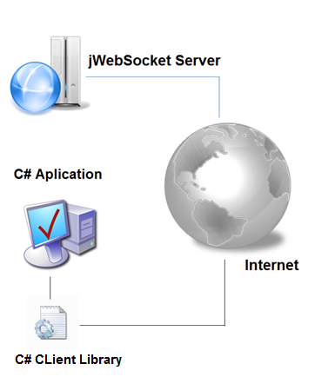
Picture 1: Model of the solution

In this diagram I would like to see the interoperability! The C# client can easily communicate with browser and mobile clients as well as with Java or Python clients. Please extend this diagram into that direction since this is a major part of the problem/solution topic.
For a client application can communicate with the jWebSocket server only needs use the C# client library to manage the communication between the application and the server.

6. Requirements for Use
Must have .NET Framework 4.0 on the PC where the application runs.

7. Roles de la solución

Application User: Interacts with the application, you can perform all actions that provide the same.
Well, I totally miss the User Interface (your Demo) in this document! This needs to be added, including screenshots. What does “Application User” mean? How does the login work, what users are available? We need a Guide for the User, even if the demo is very simple only!

8. System Operation
?? Missing content ??
9. Configurations of solution
It contains a file named config.xml in which you can change aspects of its operation.

10. Rules of solution

?? Missing content?

